ASSIGNMENT 4

NT2022TMID15338

NT2022TMID50023P

|  |  |
| --- | --- |
| TEAM ID | PNT2022TMID43019 |
| PROJECT NAME | Nutrition Assistant Application |

Question 1:

Pull an image from docker hub and run it in docker playground.

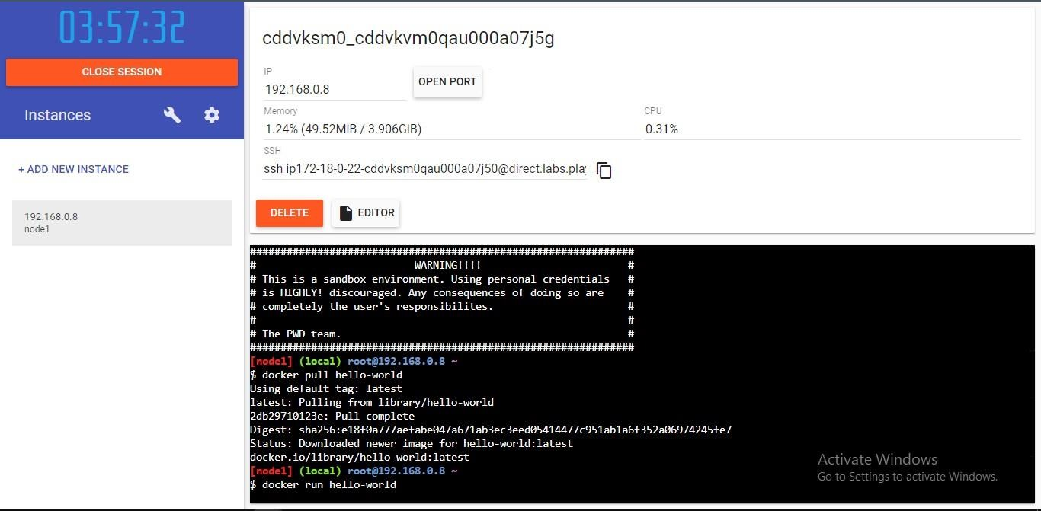

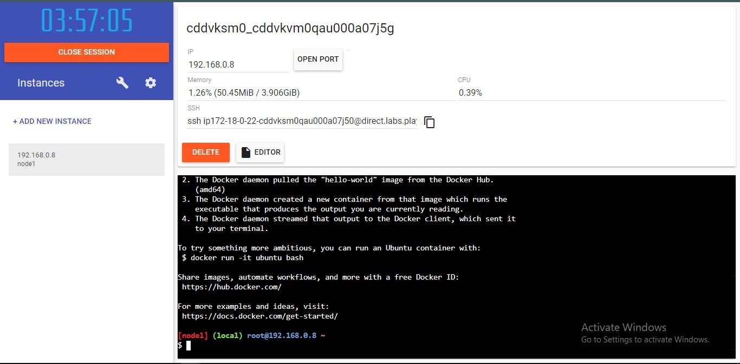

Question 2:

Create a docker ﬁle for the jobportal application and deploy it in Docker desktop application.

DOCKERFILE:

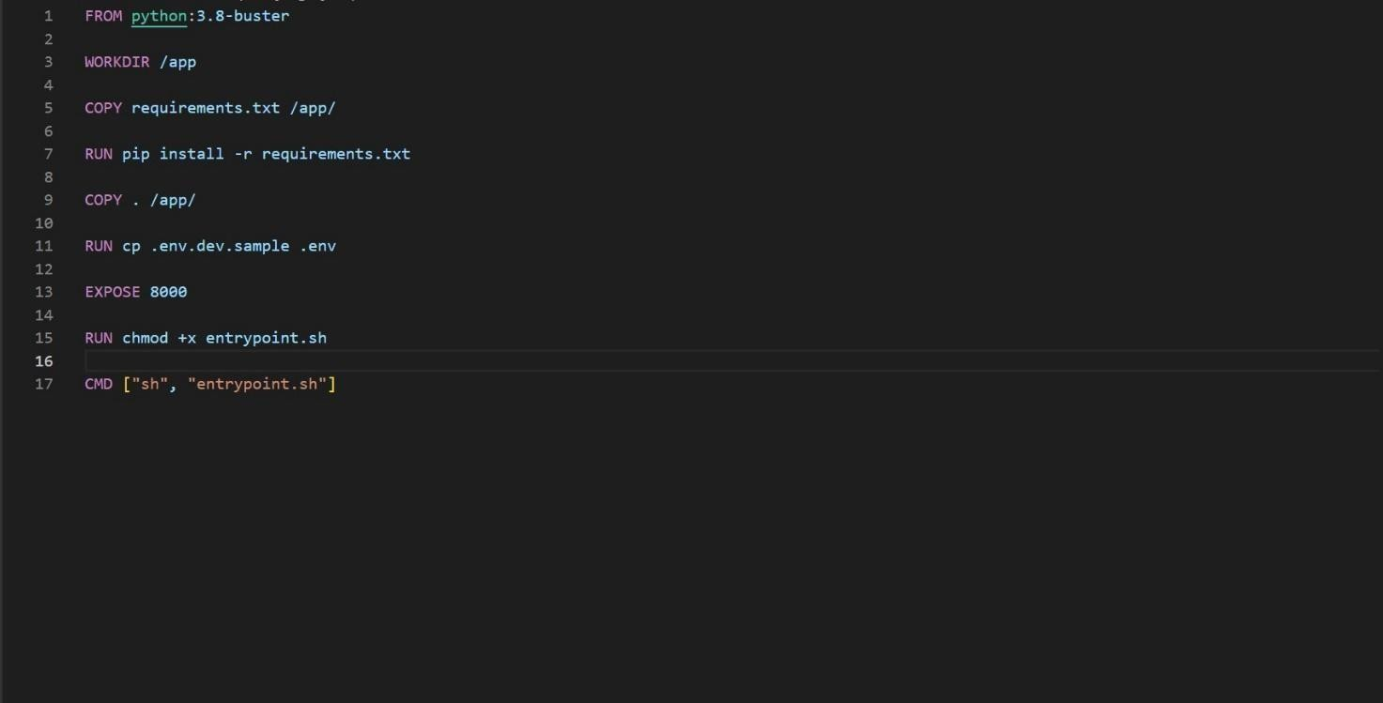

DEPLOYMENT OF JOBPORTAL APPLICATION:

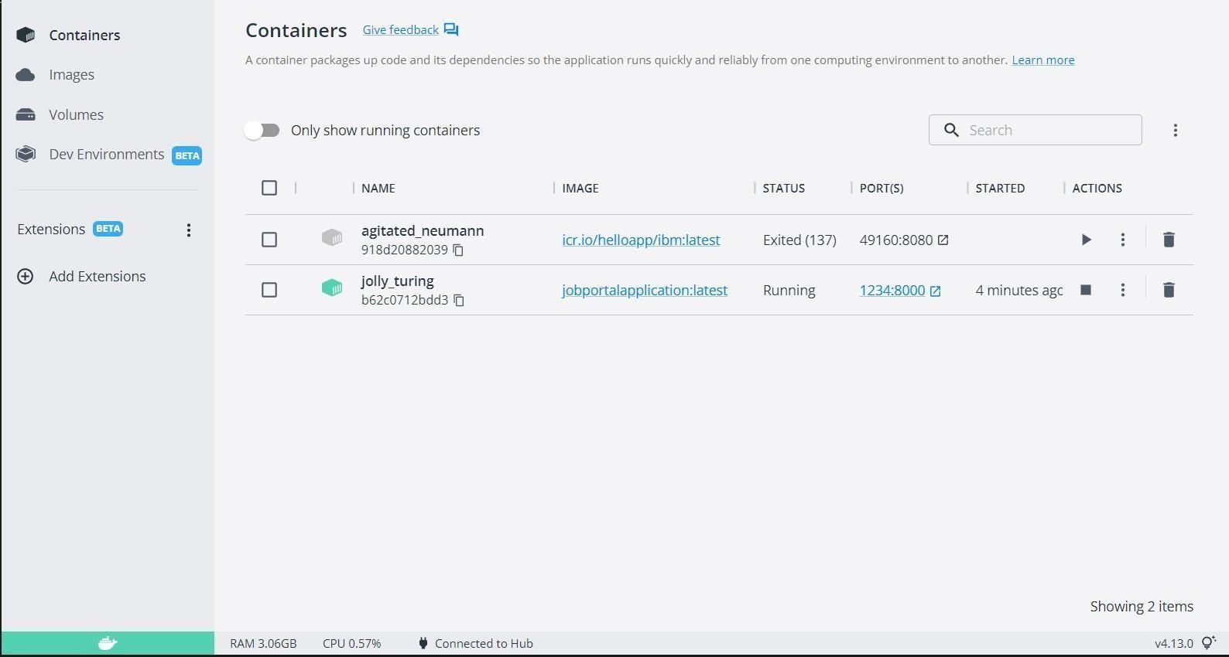

OUTPUT:

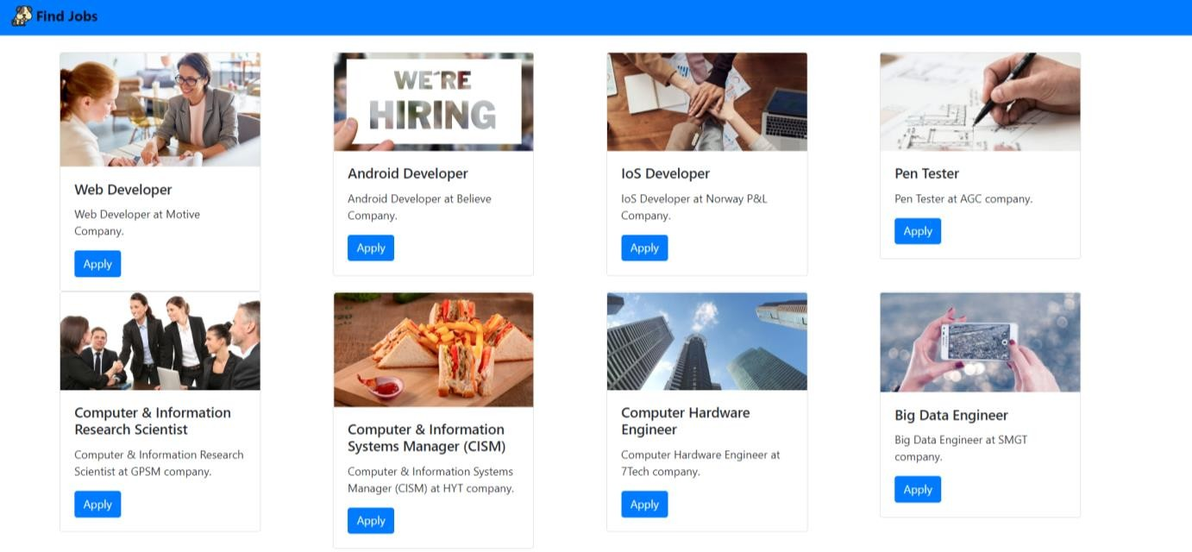

Question 3:

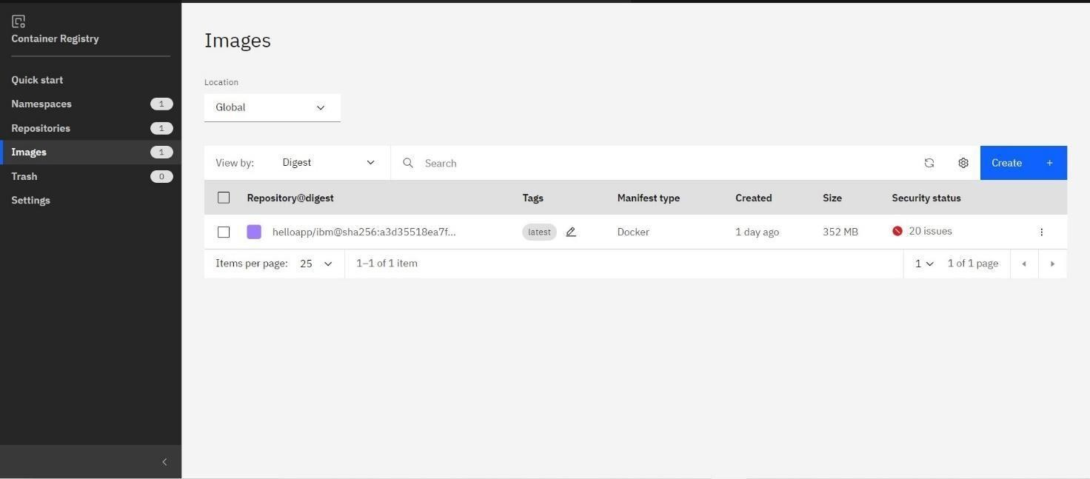Create a IBM container registry and deploy helloworld app or jobportapp. IBM CONTAINER REGISTRY DEPLOYMENT:

OUTPUT:



Question 4:

Create a Kubernetes cluster in IBM cloud and deploy helloworld image or jobportal image and also expose the same app to run in nodeport.

CREATING KUBERNETES CLUSTER IN IBM CLOUD AND EXPOSING NODEPORT:

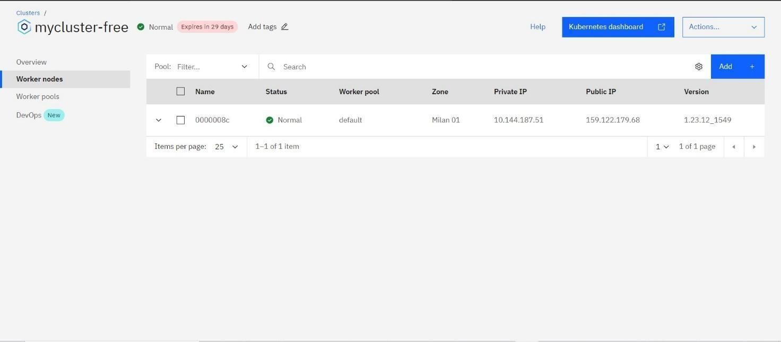

OUTPUT:

